MODULE 5 assignment:
Question 1
Capture and analyze ARP packets using Wireshark. Inspect the ARP request and reply frames, and describe the role of the sender's IP and MAC address in these packets.
ARP (Address Resolution Protocol) is used to map an IP address to the corresponding MAC address in a local network. When a device wants to communicate with another device, it first sends an ARP request to find the MAC address associated with the destination IP address. The ARP request is broadcast to all devices in the network. The device that owns the requested IP address responds with an ARP reply containing its MAC address.
Use ipconfig to find out the IP of the LAN
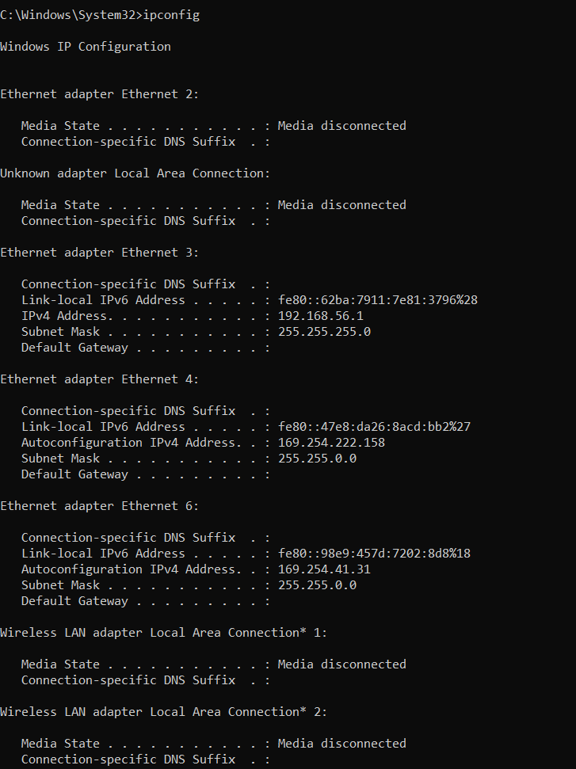
Use ping to the IP of the wifi
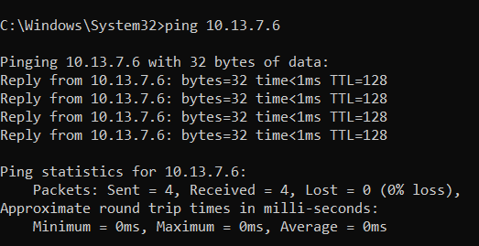
Use wireshark to capture the packets after the ping command
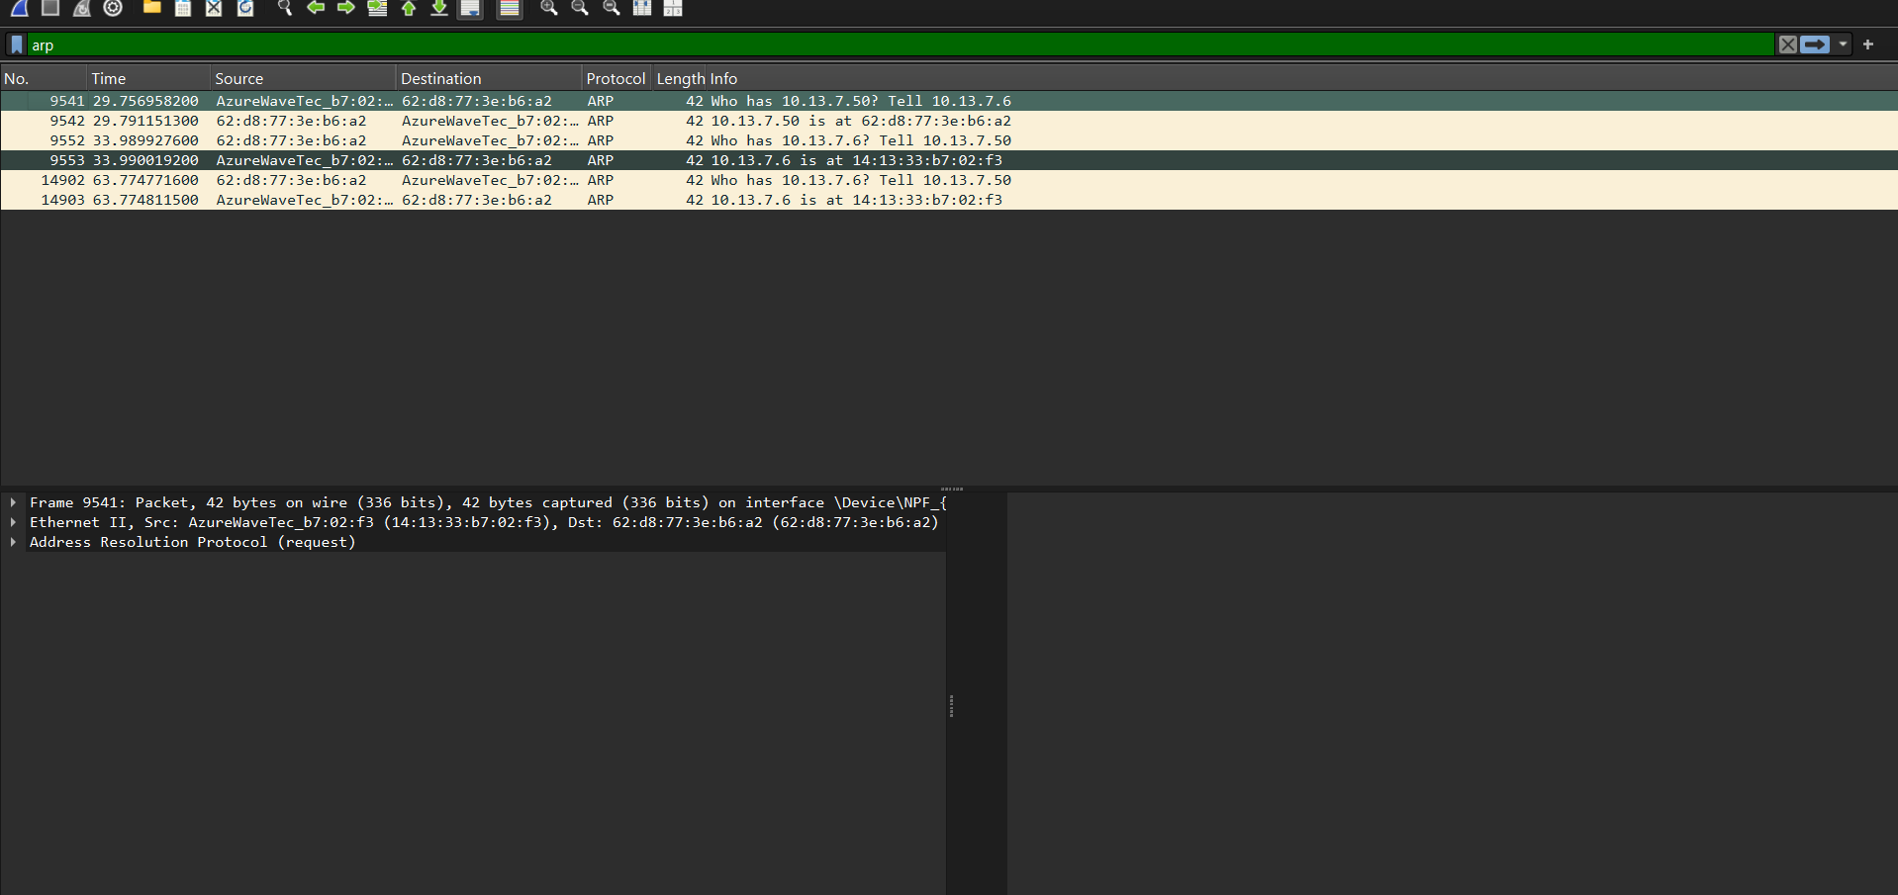

I used the filter ARP, s only MAC address is shown.

Question 2
Using Packet Tracer, simulate an ARP spoofing attack. Analyse the behaviour of devices on the network when they receive a malicious ARP response.
PC0 (Victim)
- IP Address : 192.168.1.2
- Subnet Mask : 255.255.255.0
- Gateway : 192.168.1.1

PC1 (Gateway)
- IP Address : 192.168.1.1
- Subnet Mask : 255.255.255.0

PC2 (Attacker)
- IP Address : 192.168.1.3
- Subnet Mask : 255.255.255.0

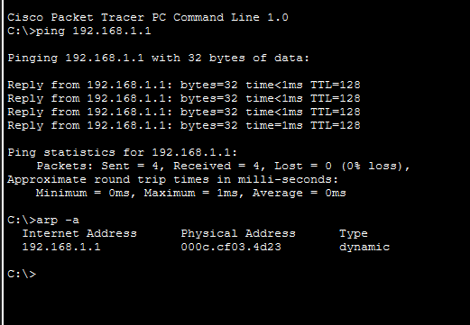
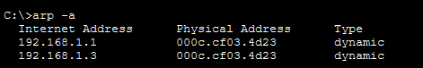
PC0 (Victim): Inadvertently updates its ARP cache with the attacker's MAC address due to the stateless nature of the ARP protocol.
PC2 (Attacker): Successfully achieves a Man-in-the-Middle (MitM) position by impersonating the default gateway's identity.
Switch0: Redirects the victim's traffic to the attacker's port based on its updated MAC Address Table.
Network Impact: All outbound data from PC0 is hijacked by PC2, allowing for packet sniffing or a Denial of Service (DoS).
Prevention: This vulnerability is mitigated in professional networks using Dynamic ARP Inspection (DAI) on the switch.

Question 3
Manually configure static IPs on the client device (like PC or your mobile phone) and verify connectivity using ping.
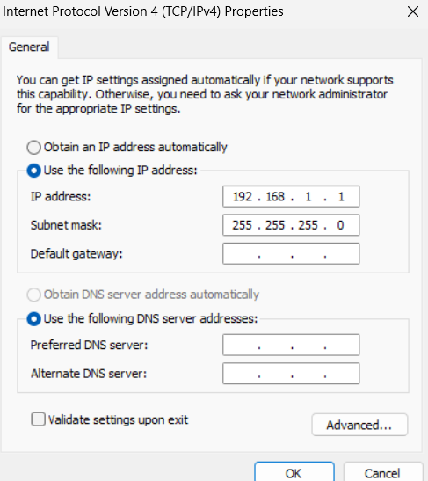

Configure staic Ip in computer
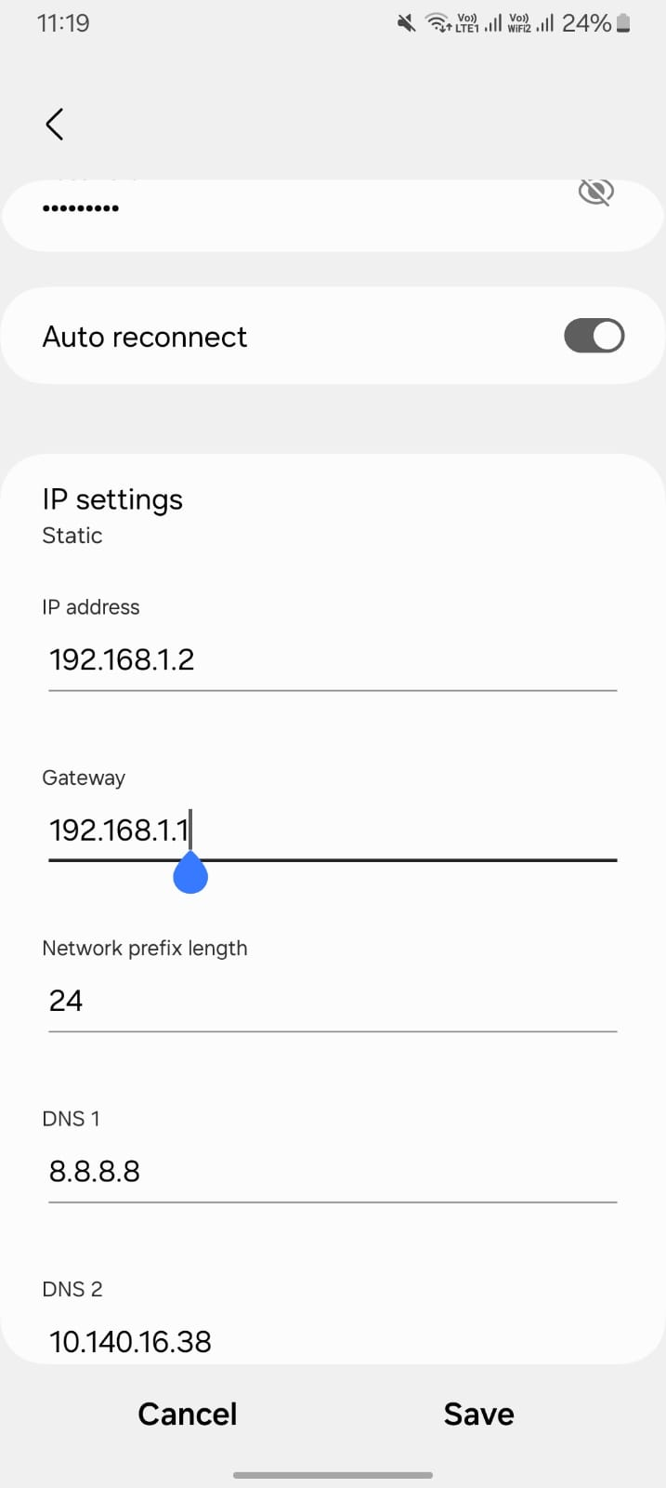
Configure static ip in phone and put the default gateway as the Ip of the computer.
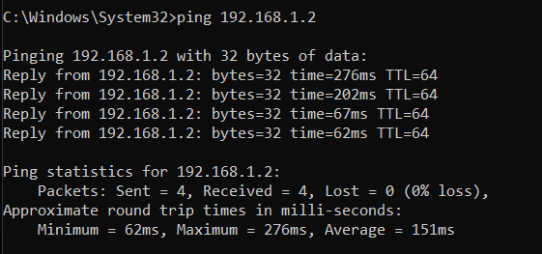
Ping to understand the connection between both we can clearly see the connection between both of them.
Question 4
Use Wireshark to capture DHCP Discover, Offer, Request, and Acknowledge messages and explain the process.
ipconfig /release: This command sends a DHCP Release message to the server, informing it that the client is vacating its current IP address. The network adapter's IPv4 configuration is cleared, and the IP is returned to the server's available pool.
ipconfig /renew: This command initiates the DORA process from the beginning. It starts with a DHCP Discover broadcast to find a server and negotiate a new (or sometimes the same) IP address and lease terms
after running these commands, wireshark capture took place
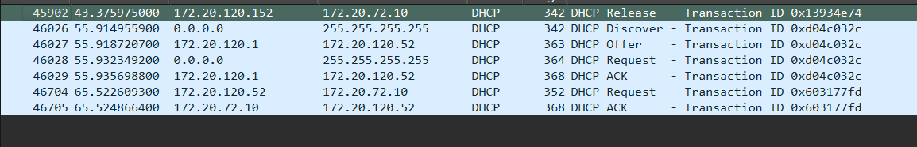
The Wireshark capture illustrates a complete DHCP transaction. It begins with a DHCP Release, where the client vacates its previous IP. This is followed by the DORA sequence (Discover, Offer, Request, ACK), during which the client broadcasts for a server and successfully negotiates the new IP address 172.20.120.52. Finally, the capture shows a Unicast Request/ACK cycle, representing a lease renewal where the client confirms its continued use of the assigned address with the DHCP server.
The captured traffic demonstrates a transition from a 'Release' state to a full 'DORA' negotiation. The consistent Transaction ID (0xd04c032c) across the four-way handshake ensures synchronization between the client and the server. The subsequent unicast messages indicate a successful lease renewal, confirming that the client has transitioned from a broadcast initialization to a stable, point-to-point management state with the DHCP server.

Question 5
Given an IP address range of 192.168.1.0/24, divide the network into 4 subnets.

Device IP Address Subnet
PC0 192.168.1.2 Subnet 1
PC1 192.168.1.66 Subnet 2
PC2 192.168.1.130 Subnet 3
PC3 192.168.1.194 Subnet 4

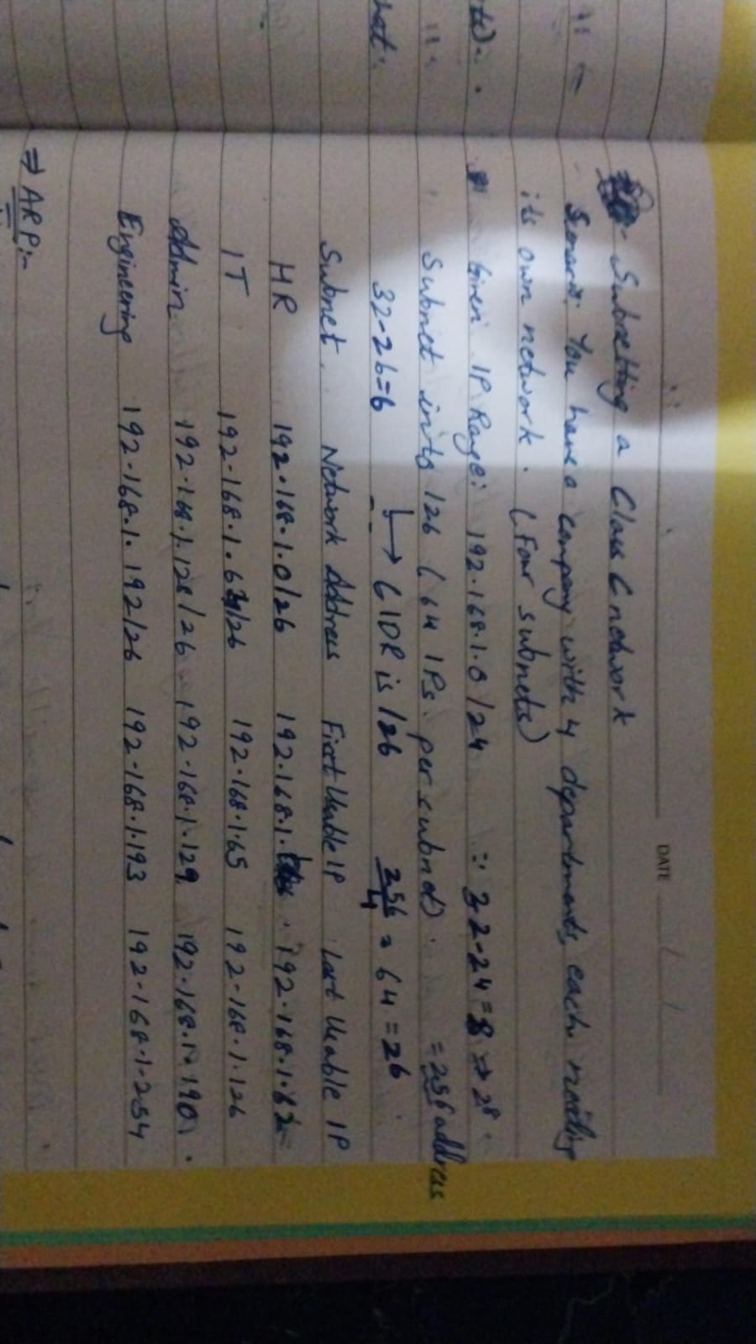

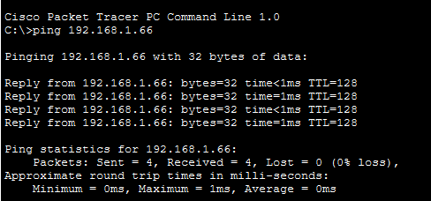

PC0-PC1

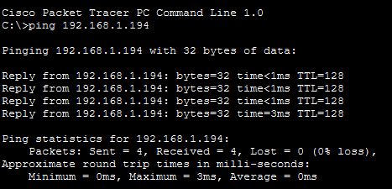

PC2-PC3

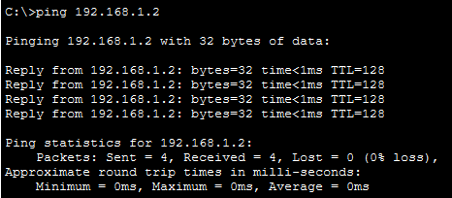

PC3-PC0
Multiple ping connections across the network have been checked and they are connected fine.

Question 6
You are given three IP addresses: 10.1.1.1, 172.16.5.10, and 192.168.1.5.
Task:
- Identify the class of each IP address (Class A, B, or C).
- Determine the default subnet mask for each class.
- Provide the range of IP addresses for each class.

IP address | Address Range | Default Subnet Mask | Class
10.1.1.1 | 1.0.0.0 – 126.255.255.255 | 255.0.0.0 | Class A
172.16.5.10 | 128.0.0.0 – 191.255.255.255 | 255.255.0.0 | Class B
192.168.1.5 | 192.0.0.0 – 223.255.255.255 | 255.255.255.0 | Class C

The class of an IP address is determined based on the value of its first octet. The IP address 10.1.1.1 belongs to Class A because its first octet falls within the range of 1 to 126, and its default subnet mask is 255.0.0.0. The IP address 172.16.5.10 belongs to Class B, as the first octet lies between 128 and 191, and its default subnet mask is 255.255.0.0. The IP address 192.168.1.5 belongs to Class C, since its first octet lies within the range of 192 to 223, and the default subnet mask for this class is 255.255.255.0.

